Staff Report
Meeting Date: April 18, 2023
To: Siskiyou County Board of Supervisors
From: Hailey Lang, Planning Director
Subject: Proposed Zone Change (Z-14-01) to rezone approximately 170 acres of Timber Production Zone (TPZ) to Rural Residential (RR) and a Use Permit (UP-11-15) to increase the allowable occupancy to 622 increase (Project Alternative Number 4) the physical size of the camp from 333 to 580 acres, and allow for additional structures and recreational features, including a pond, and ancillary facilities.

Background
Prior Approvals
The existing camp was permitted by three separate Use Permit approvals beginning in 1976. Use Permits were approved in 1976 (UP-76-39), 1985 (UP-85-37), and 1995 (UP-95-12). The 1996 Use Permit approved the current occupancy capacity of 165 guests, a maximum annual occupancy of 3,340, with an on-site parking limitation of 215 vehicles, and an average daily traffic volume of 131 vehicles. Mitigated Negative Declarations were prepared for the 1985 Use Permit (SCH #1985110397) and for the 1995 Use Permit (SCH #1996103658) project approvals. The camp also obtained approval on December 5, 1979, for a Use Permit (UP-68-79) for a 2.3’ x 3’ (6.9 square feet) directional sign to be placed at the State Highway 3/South Kidder Creek intersection. A Negative Declaration was prepared and adopted for the project (SCH #79110922).

Existing Conditions
The existing Kidder Creek Orchard Camp (KCOC) occupies approximately 333 acres. The property has been used for residential programs for more than 40 years, and continues to be operated by Scott Valley residents, both paid and volunteer, with seasonal staff hired locally and outside the area. Elevations at the site range from approximately 3,000 to 3,950 feet. In addition to Kidder Creek, which traverses the northwesterly portion of the site, a number of seasonal waterways and the Barker Irrigation Ditch traverse the site. The low elevation areas include a meadow with some jurisdictional wetlands and an apple orchard. Upland areas are generally forested with conifers, interspersed with oak trees. Natural habitats include riparian woodlands, cobbly/sandy riverbanks, wet meadows, mixed conifer forests, and oak woodlands. Surrounding land uses include timber production and open space to the south and west, and vacant lands and rural residential uses to the north and east. Kidder Creek traverses the northwesterly portion of the site for approximately 2,200 feet.

Proposed Project Summary
The project consists of a proposed rezone of approximately 170 acres and a proposed use permit to increase the capacity of the existing organized camp. The rezone would reclassify 170 acres from Timberland Production District (TPZ) to Rural Residential Agricultural, 40-acre minimum parcel size (R-R-B-40). The use permit application is to increase the allowable occupancy at the camp from 165 guests to a total occupancy of 844 (guests, staff, and volunteers), increase the physical size of the camp from 333 acres to 580 acres, and add a number of structures, recreation features, including a second pond and ancillary facilities. The proposed expansion is expected to occur over a twenty-year period. South Kidder Creek Road would continue to provide primary access to the site. Secondary emergency access would be from Patterson Creek Road and access easements to the south and east of the project site.

This project also includes a revocation of the previous use permits to consolidate all the approved uses into a single use permit and Environmental Impact Report (EIR). Therefore, all existing use permit conditions of approval and all previously adopted mitigation measures, are proposed for the new use permit where necessary. Conditions of approval and mitigation measures that are no longer necessary, have been complied with, or would be satisfied/fulfilled with new conditions of approval or mitigation measures may be eliminated. Should the proposed zone change (Z-14-01) and/or use permit (UP-11-15) not be approved, the existing use permit approvals and mitigation measures would not be revoked and would continue to be effective.
It should be noted that this project may require approvals, permits, and entitlements from other public agencies, including the following:
- California Department of Transportation (Caltrans), District 2
- California Department of Fish and Wildlife (CDFW), Region 1
- California Department of Forestry and Fire Protection (CAL FIRE)
- Regional Water Quality Control Board (RWQCB), Region 1
- Siskiyou County Air Pollution Control District
- Siskiyou County Environmental Health
- State Water Resources Control Board (SWRCB)
- U.S. Army Corps of Engineers (USACE)
- U.S. Forest Service (USFS)
It should also be noted that there are specific permitting requirements related to the emergency access road. This road connects to Patterson Creek Road. This road will be available for use as an ingress/egress route in the event of an emergency evacuation. This road will also be treated for fire fuels reduction. It will be required for KCOC to obtain necessary permits from agencies such as Cal Fire, in order to implement the emergency access road as well as complete a Timber Harvest Plan (THP).

Discussion and Analysis
Project Features
The information below describes the various existing and new features of the Proposed Project:

- Main Entrance – The entrance to the camp will remain in the same location.
- Welcome Center and Dining facility – New arrivals will be directed to the Welcome Center where the registration and administrative offices will be located along with a gift shop and infirmary. The new Dining facility would be adjacent to the Offices and situated to overlook the new Pond and Recreation area.
- Small Pond and Recreation Area – The existing areas would expand to include a new snack shack, a new restroom, and a recreation room.
- Large Pond & Recreation area – This new seven-acre pond would be built in the existing Sawmill and storage area. The source of water for supplying this pond will not change from the current source providing water to the existing pond. Along with the new pond, additional water toys and non-motorized vessels such as kayaks and canoes will also be enjoyed.
- Perimeter Road – This design allows all traffic to be on the perimeter of the camps activities, eliminating crossover of pedestrian and vehicle traffic.
- The Pines – This new area will handle the traditional camp programs currently running at Timberline and will accommodate week-long programs during the summer and weekend and weekend programs during the spring and fall. These cabins will be suitable for all season use.
- Ranch Camp – The existing program will be moved to a new, larger location closer to the camp entrance. These cabins will accommodate week-long programs during the summer and weeklong & weekend programs during the spring and fall. These cabins will be suitable for all season use.
- Equestrian Area - The existing equestrian area will move to a new location with expanded facilities that will allow for all-season use and would include an enclosed Arena and educational building.
- Base Camp - These camps have a basic campground layout with a centralized restroom and shower facility and an outdoor, covered but open dining pavilion. Campers will sleep on the ground in sleeping bags.
- High Adventure Camps – These have very simple sleeping structures, with a centralized restroom and shower facility and an outdoor, covered but open dining pavilion. Sleeping structures could be tent platforms or an open-sided, framed structure with a simple roof.
- RV Areas - These areas are not open to the public and would be used by individuals or groups working at the camp, and individuals or groups helping with or involved in a program.
- Staff Housing and Retreat Centers - The primary purpose during the summer would be housing for summer staff. During the spring & fall these structures would be used for adult retreat housing, usually on weekends.
- Staff/Guest Houses – Currently the camp has five homes on the property. These include the Warken home, the Orchard House, Cedar Lodge, Creekside, and the Jones home. They are to be used throughout the year by staff and guests.
- Staff Residence – Two of the current residences are included with the homes listed above, the Warken and Jones homes, and one more would be added in the future.
- Adult Retreat Centers - These will be used year-round and would accommodate guests staying two to six days. These cabins are suitable for all season use.
- Worship Pavilion – located on a remote and secluded hill with a panoramic view, this structure would be an open sided, covered pavilion.
- Recreation Areas – These areas are set apart for future development of recreational activities.
- Maintenance Facility – This new area will include a maintenance shop with equipment and storage facilities.
- Amphitheatre – These areas are designed for large group meetings and situated where there is a nice view and where the sound can be projected onto a hillside with a large amount of vegetation to absorb noise.
- Picnic Area/Park – This new area would be situated between the new Dining facility and the existing pond and recreation area. Designed for large groups, it would be utilized by the camp programs and for community and special events.
- Greenbelt – Designated to allow for large open spaces in the center part of the camp to protect and preserve the natural beauty of the site.
- Sawmill/Storage Area – The existing sawmill and lumber storage area would be relocated to allow for the development of the new pond.
- Water Storage Tanks – Additional water storage to accommodate the camps expansion would enlarge the existing storage tanks and add a secondary location.
- Proposed routine camp activities and uses include a horse riding/equestrian area, archery course, target range, zipline, ropes courses, a paintball course, mountain biking, waterslide, and water activities. Off-site activities include hiking, camping, horse-packing, rock climbing, river rafting, swimming, mountain biking and horseback riding on and off national forest lands.

Planning Commission Meetings

August 17, 2022, Planning Commission meeting
The proposed project was presented to the Commission at the August 17, 2022, meeting. Due to the longevity of this project and due to the high level of controversy, staff presented this item for discussion and to allow the public to provide comments. During this meeting, staff presented the proposed project and answered any questions related to the project from the Commission, as well as answered questions from the public. Requests for additional information from the Commission include:
- Ask CDFW for clarification on whether or not an LSA permit is needed.
- Address fire concerns.
- Address secondary access concerns.
- Confirm if ‘recreation’ is explicitly spelled out in the Scott River Adjudication Decree.
- Confirm whether or not the 2018 comment letter from Cal Fire is still satisfactory.
- Revising Condition of Approval #17 to be under the authority of the local fire department.

November 16, 2022, Planning Commission meeting
The proposed project was presented to the Commission at the November 16, 2022, meeting. During this meeting, staff presented the proposed project and answered any questions related to the project from the Commission. Additionally, KCOC staff had presented information on their Wildland Fire Emergency Plan. Cal Fire staff attended the meeting to answer any questions from the Commission related to KCOC’s plan, fire safety, ingress/egress, and wildfire behavior. The Commission also recommended reducing the size of the camp from 844 to 622 guests (known as Project Alternative Number 4), in order to reduce the noise impact, thus reducing the need and requirement for a Statement of Overriding Considerations. The Commission also made minor changes to the Mitigation and Monitoring Reporting Program (“MMRP”), including:

Air Quality
MM 3.1: Prior to construction activities, the project applicant shall submit a Dust Control Plan to the Siskiyou County Air Pollution Control District (SCAPCD). This plan shall ensure that adequate dust controls are implemented during all phases of project construction, including the following:
- Water exposed earth surfaces as necessary to eliminate visible dust emissions;
- When grading within 100 feet of any residence, park or other sensitive receptor boundary, utilize pre-soaking with sprinkler or water trucks in addition to normal watering for dust control;
- Suspend grading operations when wind is sufficient to generate visible dust clouds;
- Pave, use gravel cover, or spray a dust agent on all haul roads;
- Impose an onsite speed limit on unpaved roads to 15 mph or lower (this speed must be posted);
- All grading operations shall be suspended when sustained wind speeds exceed 25 mph;
- All exposed surfaces and overburden piles shall be revegetated or covered as quickly as possible;
- If fill dirt is brought to, or stockpiled on, the construction site, tarps or soil stabilizers shall be placed on the dirt piles to minimize dust problems;
- Clean earthmoving construction equipment as needed to ensure that haul trucks leaving the site do not track dirt onto area roadways;
- Cover all trucks hauling soil, sand, and other loose materials and ensure that all trucks hauling such materials maintain at least two feet of freeboard;
- Institute measures to reduce wind erosion when site preparation is completed;
- Install sandbags or other erosion control measure to prevent silt runoff onto public roadways;
- Designate a person or persons to monitor the dust control programs as approved by the SCAPCD, and to order increased watering, as necessary, to prevent the transport of dust off site. This designee’s duties will include holiday and weekend periods when work may not be in progress. A phone number of the applicant’s designated contact person shall be included in the Dust Control Plan and updated as necessary.
- The approved Dust Control Plan shall be included on all development plans, including, but not limited to building permit plans and grading plans.

Hazards and Hazardous Materials
MM 8.1 Prior to the initiation of construction of habitable structures for the Proposed Project, the emergency access road will be developed by the Project and approved as to form and function by the California Department of Forest and Fire Protection (CAL FIRE) and the Siskiyou County Public Works Department. Additionally, all CAL FIRE required improvements to existing Project roadways shall be implemented. These roadways and the new access roadway shall be maintained by the Project, verified for compliance of the CAL FIRE roadway safety requirements at the start of each Kidder Creek Orchard Camp recreation season by a CAL FIRE approved wildfire expert, and re-approved on an annual basis. or as the County and CAL FIRE determines necessary.

Lastly, there was a lengthy discussion from the Commission regarding a comment letter dated November 16, 2022, submitted by attorney Marsha Burch on behalf of a group identified as ‘Keep Scott Valley Rural’. Issues in that letter were addressed in staff’s report to the Board of Supervisors on December 13, 2023.

December 13, 2022, Board of Supervisors meeting
At the December 13, 2022, Board of Supervisors meeting, staff summarized the project in a verbal presentation and then the Chair opened up the public hearing where members of the public were able to submit public comment. The chair closed the public hearing and brought the item back to the Board for discussion and potential action. The Board unanimously voted to take the project back down to the Planning Commission level for additional clarification and deliberation. Subsequently, after staff met with a member of the Board, staff undertook to address certain issues further, and a summary of the concerns include:
- Fire hazards: 4290 regulations, catastrophic fire modeling, and emergency road access.
- Pond: further clarification related to the Evaporation Water Loss study by Chris Cummings.
- Zoning: additional clarification on allowed uses subject to Use Permit approval within the Rural Residential zoning district.
- Biological Resources: concern was raised regarding the potential issue of the Northern Spotted Owl and Bald Eagle.
- Incorporated of the Mitigation Monitoring and Reporting Program (MRRP).

January 18, 2023, Planning Commission meeting
During the January 18, 2023, meeting, staff presented on the concerns from the Board of Supervisors:

Fire Hazards
Concerns: First, it was communicated that there is a potential danger that Patterson Creek and the proposed escape routes circle back to the direction of Cheeseville from where a fire could well originate and that it may be necessary to consider an alternative route to the north. Second, fire behavior analysis was requested to be conducted through FSPro (a computer program simulating predicted rates and area spreads of fire), primarily to review fire behavior from fires starting near Cheeseville to be presented and discussed at the Planning Commission meeting. Third, any road to be constructed in excessive slope areas be constructed to protect against erosion. Fourth, the Board requested for staff to explore ability of the camp to utilize Project Activity Levels (PALs), which are decision-making tools designed to help fire and timber resource managers establish the level of industrial precaution for the following day, such as precautionary evacuations. Lastly, the Board wanted staff to explore whether Public Resource Code Section 4290 standards speaking to signage for evacuations, storage water requirements, and greenbelt requirements should be further addressed.

Planning response: In terms of additional evacuation routes during an emergency, staff mentioned that KCOC will utilize any and all routes dependent upon the emergency and the direction of travel staff and guests are able to go, including an alternative route to the north, which would likely be accessed via foot. This was discussed during the meeting, and the Commission felt an emergency access to the north was not realistic or inadequate. Office of Emergency Services (OES) Director Bryan Schenone prepared additional mapping (see figures 1-3 on the following page), by utilizing the information contained within the EIR and the KCOC-authored Wildland Fire Emergency Plan, for the Planning Commission meeting which delineated the time it will take to evacuate should a fire near Cheeseville occur. The analysis confirms that the camp has approximately 6-8 hours of evacuation time prior to a catastrophic fire setting on KCOC property. This analysis is in line with the analysis conducted by KCOC, which was presented to the Commission during the November 2022 meeting. It was further discussed that KCOC will implement any 4290 regulations, should those standards be imposed by Cal Fire; Darryl Laws (Cal Fire) is Siskiyou County’s identified local fire warden and is allowed to impose additional requirements and standards outside of Cal Fire requirements and standards.

Figure 1: Cal Fire, Fire Modeling Map 1

Figure 2: Cal Fire, Fire Modeling Map 2

Figure 3: Cal Fire, Fire Modeling Map 3

Pond
Concerns: Staff was requested to review whether the proposed pond requires downhill channeling from Barker Ditch and thus is not only a pass-through but a diversion. Staff was also asked to review the evaporation study by Chris Cummings related to the methodology used and requested that this be discussed during the Planning Commission meeting. Third, whether or not the “leaky ditch” regulation would result in curtailment of Barker Ditch in the future. Given these considerations, the question arose, would the project have a reduced number of participants at any given time if there is no pond? Also, is there a need to condition that wells are for domestic use only?

Planning response: Staff presented the methodology used in the evaporation study by Chris Cummings and will ask Chris Cummings to present his reasoning for said methodology. It is the staff’s opinion that the study utilizes accurate methodology to realistically capture evaporation of the project area.

Ultimately, the decision as to whether the channeling from Barker Ditch to the proposed pond should be classified as a diversion is a legal determination for the California State Water Board, though it arguably appears that the secondary channel could be classified as a diversion under Water Code Section 5100(c). If a diversion is determined to exist, then KCOC may be required to file a statement of diversion with the SWRCB unless the diversion comes within one of the various exceptions under Water Code Section 5101, including that the diversion is included in a watermaster’s annual report or that the diverter has otherwise obtained a permit. As pertains to the present project, the conditional use permit requires that all other agency approvals must be obtained in order to operate under the use permit. Presently, KCOC maintains it is not subject to SWRCB jurisdiction because its water rights exist pre-1914 (when the state first began issuing regulatory water permits) but is subject to the Scott River Adjudication Decree, which is a 1980 Siskiyou Superior Court judgment and order governing water rights to the Scott River.

As to the “leaky ditch regulation,” generally the Deputy Director for the division of Water Rights may now issue a curtailment order when flows of certain rivers, including the Scott River, drop below certain minimums unless diversions from the river are curtailed. The purpose of the curtailment is to insure salmon habitat. (23 CCR § 875). An exception is made at Title 23, Article 23.5 of the California Code of Regulations at Section 873.5 (23 CCR § 873.5), which sets forth that though a channel might otherwise be curtailed due to seepage, if there is a need for livestock watering. Under 23 CCR 875, the Barker Ditch could be curtailed depending on the Scott River water levels, and an exception is not made for recreational uses.

The groundwater well is dedicated to domestic use only. Any well permit applications must make the selection of use for the well for which they apply for. The applicant must check a box on the form that specifies use (i.e., domestic, agricultural, industrial, etc.). In any case, if KCOC applies for and receives a permit for the domestic designation, the use of the groundwater is by virtue of the permit issuance for designated for domestic uses.

Zoning
Concerns: Another issue raised was the density of the recreation taking place at the camp and whether that level of recreation should be considered “commercial.”

Planning response: Section 10-6.1502 sets forth that certain land uses require a conditional use permit. Among those uses are “recreational facilities, privately operated.” The term “recreational facility” is defined in the Zoning Ordinance as a “place designed and equipped for the conduct of sports, leisure time activities, and other customary and usual recreational activities.” The term “privately operated” is not defined but KCOC is privately operated and therefore would come within the definition “recreational facility, privately operated).

To the extent that in a previous staff report, staff relied on a narrower term, “recreational facility, private,” that term is defined as “recreation facility operated by a nonprofit organization and open only to the bona fide members and guests of such nonprofit organization.” Public comment was received that “guests” does not necessarily imply public members who are attending. Staff’s response is twofold: First, it is very likely that the interpretation described above is the better one as “privately operated” naturally encompasses uses that are otherwise open to the public. Second, the term “guests” is not defined, and it is common usage and reasonable interpretation that paying public to private establishments, such as hotels and motels, are referred to as “guests.”

Ultimately, KCOC appears to be a privately operated recreational facility, as such use is allowed under Section 10-5.1502(c).

Biological Resources
Concerns: Concerns were raised that the Biological Resources assessment did not include the Northern Spotted Owl or Bald Eagle.

Planning response: Both the Spotted Owl and Bald Eagle are identified in the amended Wildlife Resources Report prepared by Wildlife Biologist Jamie Allen. The Spotted Owl and Bald Eagle are discussed in section Procedures and Findings of the report. Additionally, the Wildlife Resources Biological Assessment for the emergency road access portion of the project mentions that:

“This Wildlife Resources Report identifies the potential effects of the proposed action(s) under the project, on threatened or endangered species listed under the Federal and California Endangered Species Acts (ESA) or on their designated critical habitat in accordance with the ESA and regulatory guidance. We considered organisms that only appear on the official species list generated through CNDDB nine quad search for state listed species and The U.S. Fish and Wildlife Service IPaC trust resource report both created on 2/18/2019 (USFWS IPaC Consultation Code: 08EYRE00-2019-SLI-0069, Event Code: 08EYRE00-2019-E-00166).”

“Species that will not be affected by the proposed activities will be considered briefly and eliminated, with justification, from further, more detailed consideration. We will consider in detail those species that may be present in the action area and may be affected by the proposed activities. This document is prepared in accordance with the requirements of the ESA and its implementing regulations.”

It was determined that through this analysis, the Spotted Owl was dropped from further detailed analysis due to the canopy not meeting the minimum requirements. The Bald Eagle was also dropped from further detailed analysis due to there not being any active Bald Eagle nests within .25 miles of the proposed project area.

Mitigation Monitoring and Reporting Program (MMRP)
Concern: There was a concern raised that the MMRP was not included for review and approval during the November Planning Commission meeting.

Planning response: Although not legally required, Staff incorporated the MMRP into the staff report package for review and approval.

February 15, 2023, Planning Commission meeting
It was of the request of the Commission to further discuss the concerns from the January meeting, particularly concerns related to fire and water usage. The purpose of this meeting was to further discuss concerns in the record and/or further clarify information already presented to the Commission. The Commission had also made additional revisions to the MMRP. The Commission voted to send the project up to the Board of Supervisors.

During this meeting, the Commission concluded that they had discussed wildfire concerns in length and added mitigation measures to strengthen mitigation against wildfire impacts. It was noted that wildfire was added as an independent Environmental Impact Area of CEQA in 2019, after the Notice of Preparation date for this project. At the time of this project’s review, wildfire was an impact that was analyzed under the Hazards and Hazardous Materials Environmental Impact Area of CEQA. Related to the pond, the Commission concluded that there were no additional issues to discuss, as the State Resources Water Board (SRWB) has responsibility to permit the pond, which is beyond the purview of the Planning Commission. The Commission had discussed with Jamie Allen, author of the wildlife biology study, that both the Spotted Owl and Bald Eagle were accounted for. It was of the Commission’s view that the project meets the County’s zoning requirements, as well as the SVAP. It was also communicated that the SVAP does not define uses, so much of the plan and its policies are subjective and up to interpretation.

The Planning Commission made the following changes to the MMRP, including:

Hazards and Hazardous Materials
MM 8.1 Prior to the initiation of construction of habitable structures for the Proposed Project, an emergency access road will be developed by the Project and approved as to form and function by the California Department of Forest and Fire Protection (CAL FIRE) and the Siskiyou County Public Works Department. This road will be designed and constructed to handle loaded goosenecks/stock trailers. Additionally, all CAL FIRE required improvements to existing Project roadways shall be implemented. These roadways and the new access roadway shall be maintained by the Project, verified for compliance of the CAL FIRE roadway safety requirements at the start of each Kidder Creek Orchard Camp recreation season by a CAL FIRE approved wildfire expert, and re-approved on an annual basis.
MM 8.2 Should a wildfire occur near KCOC, and the Camp be put under an ‘Evacuation Warning,’ the Camp shall immediately evacuate the Camp. KCOC will enter into an MOU with Siskiyou County OES memorializing this requirement.
MM 8.3 When fire conditions exceed the Fire Danger Burn Index of 97 percentile, the Camp will provide additional and adequate transportation onsite. KCOC will enter into an MOU with Siskiyou County OES memorializing this requirement.
MM 9.1 Prior to any land disturbance activities associated with the construction of the proposed seven-acre pond, the following shall be completed:
- If the dam necessary to impound the proposed pond is subject to Department of Water Resources, Division of Safety of Dams jurisdiction, proof of full compliance with the required permitting and plan approval shall be provided to the Siskiyou County Community Development Department – Planning Division; or
- If the dam necessary to impound the proposed pond is not subject to the Department of Water Resources, Division of Safety of Dams jurisdiction, the applicant shall submit plans to the County, stamped by a qualified engineer registered in the State of California, detailing the structural design of the dam. The County will review and approve said plans to ensure that the proposed dam is structurally adequate and is not a hazard. The applicant shall be responsible for paying all costs associated with the County’s review of said plans. The County retains the right to hire a third-party engineering firm to review the required plans.
- Consultation with the State Water Resources Control Board Division of Water Rights to determine if any changes to the existing water rights or any permitting is required for the filling of the pond. If revised water rights and permits are required, proof of full compliance with the required permitting and plan approval shall be provided to the Siskiyou County Community Development Department – Planning Division. All consultation and resulting requirements with the SWRCB shall be provided to the California Department of Fish and Wildlife – Region 1.
Biological Resources
MM 4.7 A no-disturbance buffer of 150-feet from the active channel of Kidder Creek. edge of a bank, edge of the floodplain, or outer edge of the riparian dripline shall be established to the specifications of the California Department of Fish and Wildlife (CDFW). The Project shall result in no net loss of riparian habitat.
MM 4.8 Prior to the implementation of the fuel loads reduction plan, a biological survey will be conducted by a qualified professional to account for the Spotted Owl.
MM 4.9 Prior to the implementation of the fuel loads reduction plan, a biological survey will be conducted by a qualified professional to account for the Bald Eagle.
Fire Behavior Analysis
At the request of the Board of Supervisors an additional fire behavior analysis was conducted to further clarify in the record the existing conditions of fire behavior in and around the location of KCOC. Figures 4 and 5 show the historical wind conditions at the Quart Hill Raws station from July 15 to September 30. Figure 5 shows the winds that are most problematic, including 135, 225, and 270 degrees. The worst-case scenario at 25 MPH is at 135 degrees, which is what was used in this fire behavior model. The wind direction and speed are static for this model’s run. The ignition in this model started on the west side of Highway 3 from Patterson Creek Road to Valley Pines Road.

This model run was set at two 8-hour burn periods for a total of 16 hours. Figure 6 shows the short-term fire behavior model input. This figure shows the potential under the model’s assumptions which include, no fire suppression, no barriers were used, and the wind at 135 degrees at 25 MPH. The area within the fields called for a Fuel Model 102 (which is a low-load dry climate shrub). The other model ran a Fuel Model 102 to Fuel Model 93 (which includes agriculture fields). This matches with some irrigated fields but not the fire behavior of drier agriculture fields. The thick dark red lines represent the time of arrival and not heat signatures. It is a 16-hour run and each line and color show how long it would take to get to that point. Figure 10 shows the Scott Reinhardt Crown fire method. The model information used was the same as the other models shown.

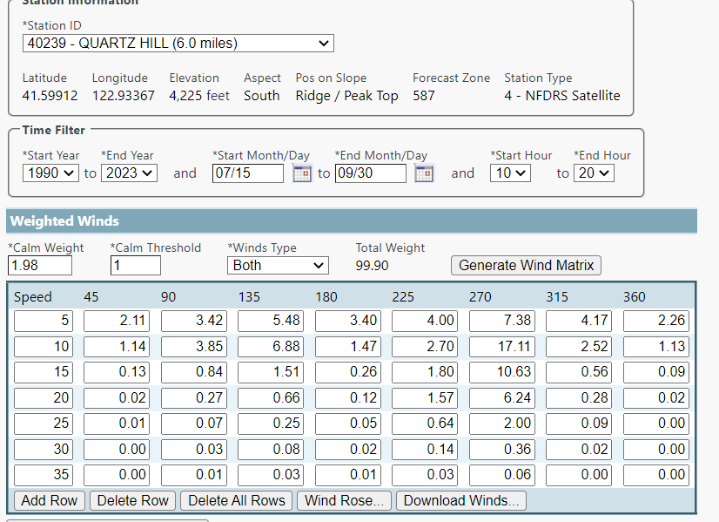
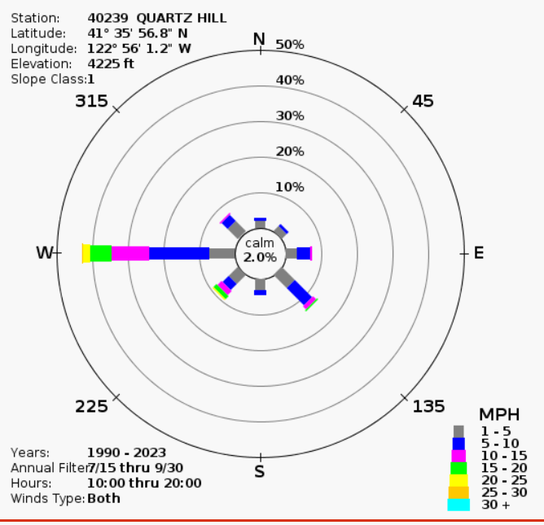
Figure 4: Historical Wind Conditions
Figure 5: Wind Speed Patterns
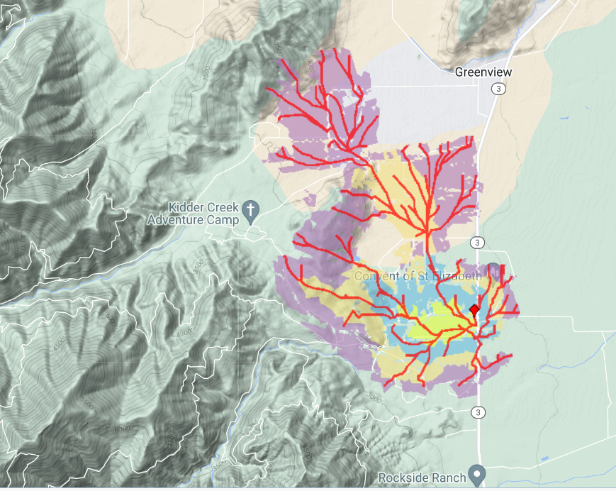Figure 6: Short-Term Fire Behavior Model Input, Fuel Model 102
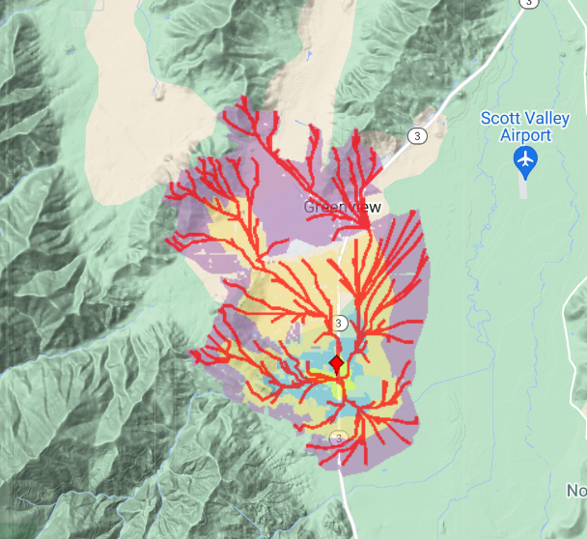
Figure 7: Short-Term Fire Behavior Model Input, Fuel Model 93

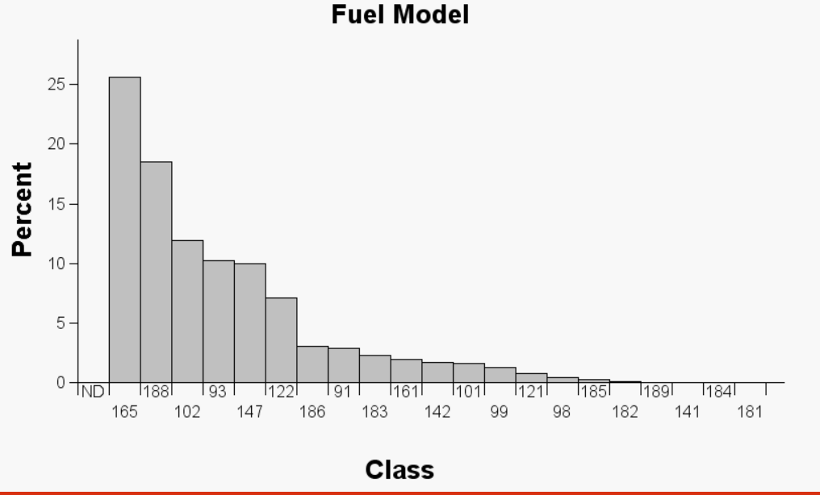
Figure 8: Fuel Model Classifications
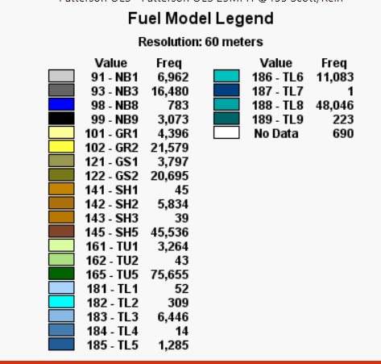
Figure 8: Fuel Model Legend

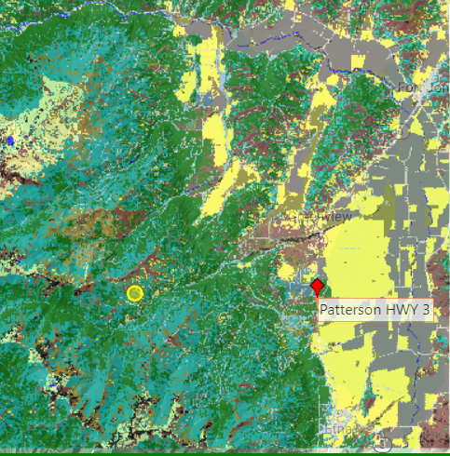
Figure 9: Types of Fuels
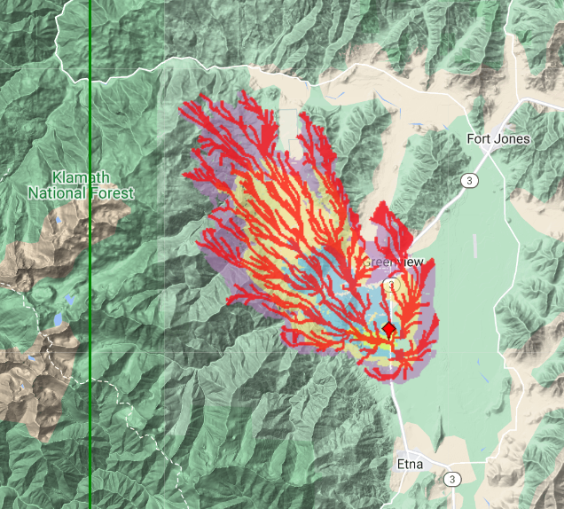
Figure 10: Scott Reinhardt Crown Model

General Plan and Scott Valley Area Plan (SVAP) Consistency

General Plan
A General Plan is a broad, long-range policy document that guides future development, conservation, and is a comprehensive collection of goals and policies related to a multitude of aspects of community life. In California, cities and counties are required by State law to have a General Plan. It is the local government’s long-term blueprint for future development.

The Land Use Element of the Siskiyou County General Plan identifies the project site as being within the mapped resource overlay area for Soils: Erosion Hazard; Wildfire Hazard; Soils: Severe Septic Tank Limitations; Slope; Flood Hazard; Surface Hydrology; Wildfire Hazard; and Woodland Productivity. Planning staff has identified that Composite Overall Policies 41.3(a), 41.3(c), 41.3(e), 41.3(f), 41.5, 41.6, 41.7, 41.8, 41.9, 41.10, 41.12, 41.13, 41.18, and 41.19(b) apply to the proposed project.

Scott Valley Area Plan (SVAP)
Area and community plans address a particular region or community within the overall planning area of the general plan. An area or community plan is adopted as a general plan amendment. It refines the policies of the general plan as they apply to smaller geographic areas and is implemented by local ordinances such as those regulating land use and subdivision. Area or community plans also provide forums for resolving local conflicts among competing interests.

Specific to the KCOC project site, a portion of the project site, mainly consisting of the flat meadow and orchard areas, is designated as Prime Agricultural Land, as shown on the Scott Valley Area Plan Natural Resources Map 3. Kidder Creek Orchard Camp predates both the Scott Valley Area Plan and the current General Plan. The proposed expansion of the camp does not include any structures or other permanent type uses on those areas designated as Prime Agricultural Land. This area has been used for passive recreational uses in the past and will continue to be used for similar uses.
Figure 11: KCOC project site, red=excessive slope, green=non-resource area, yellow=prime agriculture

Much of the project site is classified as Non-Resource Area, which represents the portions of the Scott Valley Watershed that do not contain any particular natural resources or physical hazards. The project site is also classified as Excessive Slope Area, which is defined as 33 percent or greater natural slope constitutes slope that is excessive from a water quality standpoint. The development goals for all Non-Resource Areas are as follows:

- Development Goal #6: All development in non-resource areas shall be of a density or intensity that is compatible with existing use of the land.

- Development Goal #7: All development that is in non-resource areas shall be of a density or intensity that will channel all intense or dense development close to existing public services; the impacts of this development should not overburden existing public services, nor degrade water quality.

Page 21 of the SVAP notes, “However, non-resource areas within the watershed do not have development policies applied to them as yet. As previously mentioned, non-resource areas are the portions of the Scott Valley Watershed that do not contain any outstanding natural resource or physical hazards. In order to set forth future development patterns in non-resource areas, the following development policies shall apply:”

- Policy #31: Only agricultural, residential, open space, and small-scale commercial, industrial, recreational uses, and public or quasi-public uses may be permitted.

KCOC is defined as a recreational use, which is permitted as part of this policy. The SVAP does not define any of the above uses, so the definition of uses has been vetted at the Planning Commission level, it was confirmed by the Commission that the use of KCOC is defined as recreational, not commercial, or industrial.

- Policy #32: Residential, small-scale commercial, industrial, recreational uses, and public or quasi-public uses may only be permitted when they are clearly compatible with the surrounding and planned uses of the land.

Since the inception of KCOC, the uses have been recreational, and will continue to be.

- Policy #33: The minimum parcel size permitted are those as specified on the Comprehensive - Composite Plan map (Map XII).

The project site has parcels which meet the size requirements of SVAP. It is not a part of the proposed project to change the sizing of any of the parcels within the camp.

Continuing on page 21, “Density policies in non-resource areas range from minimum parcel sizes of 5 acres to 40 acres. Additionally, the following policy is applied to all areas of the Scott Valley Watershed:”

- Policy #34: If more than one development policy affects the same parcel of land, the most restrictive development policy shall apply, first, followed by the other policies in order of diminishing restrictions.

The project site includes a range of density policies, including five-, ten-, and 40-acre minimums.

Major Goals 2 and 4 and the need to have adequate access to all development, have resulted in the following development policies that shall apply to all development regardless of where it is located within the watershed boundaries:

- Policy #35: All development will be designed so that every individual parcel of land created is a buildable site, and will not create erosion, runoff, access, fire hazard, resource protection, or any other environmentally related problems. This policy shall apply to all proposed uses of land.

The development to occur on KCOC is within the non-resource policy land, and not the excessive slope land. The development will not create erosion, or any other hazards identified in this policy. Environmental impacts have been fully analyzed through the CEQA process.

- Policy #36: Safe buildable access must exist to all proposed uses of the land. The access must also be adequate to accommodate the immediate and cumulative traffic impacts of the proposed development.

The access to and from the project site and all of the parcels have been deemed adequate and were not indicated as significant impacts through the CEQA process.

The following policy serves to further clarify standards throughout Scott Valley:

- Policy #37: The policies of this plan shall not apply to developments functioning and legally existing prior to the adoption of this plan.

KCOC has functioned and legally existed since 1977, before the adoption of the SVAP.

Additionally, there needs to be a reasonable degree of flexibility in density requirements and at the same time stay within the policy intent applied to each resource and physical hazard map. In order to satisfy this concern, the following policies are established for all areas within the watershed boundaries:

- Policy #38: None of the policies stated in this plan will apply to Boundary Line Adjustments, so as long as the new parcel configurations(s) and sizes conform to the intent of the density permitted in each resource, physical hazard, and non-resource area. All new parcel configurations and sizes must conform to all requirements of the applicable zoning districts.

The project is not proposing to reconfigure any parcels.

In order to ensure that all major plan goals are achieved, the following development policy shall apply to all land within the Scott Valley Watershed:

- Policy #42: It is the policy intent of this plan to channel heavy commercial and industrial land uses into areas that have good, existing access, away from residential areas, and into the existing urbanized areas of Fort Jones, Etna, Callahan, and Greenview. This policy may not be applicable to industries that are specifically related to timber production, agricultural production, and mining so as long as they specifically conform to the policy intent applied to each resource area, physical hazard area, and non-resource area.

There are no heavy commercial or industrial uses proposed with this project.

Zoning Consistency
In concert with the General Plan and Scott Valley Area Plan, the Siskiyou County Code establishes zoning districts within the County and specifies allowable uses and development standards for each district. Under state law, each jurisdiction’s zoning must be consistent with its general plan. The area of the project site currently zoned TPZ is proposed to be changed to Rural Residential Agricultural, 40-acre minimum parcel size (R-R-B-40). Pursuant to Section 10-6.4802 of the Siskiyou County Code, the R-R-B-40 district permits single-family dwellings and residential accessory structures and uses. Existing zoning on the rest of the project site is Prime Agricultural District, 80 acre-minimum parcel size (AG-1-B-80); Rural Residential Agricultural, 5- acre minimum parcel size (R-R-B-5), Rural Residential Agricultural, 10-acre minimum parcel size (R-R-B-10), and Rural Residential Agricultural, 40-acre minimum parcel size (R-R-B-40).

Siskiyou County Code (SCC) Section 10-6.1502(c) allows for recreational facilities in any zoning district upon approval of a conditional use permit. In addition to the zone change described in the previous paragraph, the applicant is requesting a use permit, pursuant to SCC Section 10- 6.1502(c) and 10-6.1201 et seq. to expand occupancy, acreage, and additional structures for recreational use of the property. Under that section specifically are allowed “recreational facilities privately operated” and “public celebrations.” The use of “public celebrations” has historically within the County been used to permit uses such as wedding venues. As to “recreational facilities privately operated,” staff previously indicated that was the general category to which the KCOC project would otherwise fit under.

Public comment indicated concern that because “private recreational facility” is defined in the County Code as meaning a non-profit organization’s facility for its members and guests and would not cover, for instance, public access to the camp upon payment of a fee, First, the term “guest” is not defined in the Zoning Ordinance and as otherwise reasonably interpreted means any person allowed on the property at the consent of KCOC, paying or not. For instance, it is common to speak of the “guests” of a hotel, which “guests” are in fact just members of the public paying to stay at the hotel. It is certainly a reasonable interpretation that a “guest” of the KCOC may be a paying member of the public there at the permission of KCOC. Second, even if KCOC is still not considered to fit “cleanly” within the definition of a “recreation facility, private” but it is not otherwise open to the public for the most part, and thus not a commercial recreational facility, then it otherwise appears KCOC aligns with the general scope of 106.1502(c) in terms of activities – resorts, amusement parks, recreational facilities and public celebrations.

Kidder Creek Orchard Camp Project Impact Vs. Single Family Development Potential Build Out
KCOC Project Domestic Water Use Comparison and Wastewater Disposal Density Standard Evaluation
Parcel Unit | Ownership | APN | Zoning | Acres | SVAP Split Potential
Parcel 1 | KCOC | 024-440-330 | RR-B-5 | 22.65 | 4
Parcel 2 | Warken, Andrew | 024-440-310 | RR-B-5 | 12.5 | 2
Parcel 3 | KCOC | 024-440-320 | RR-B-5 | 1.79 | 1
Parcel 4 | KCOC | 024-450-590 | AG-1/RR-B-5 | 10 | 2
Parcel 5 | KCOC | 024-450-390 | AG-1/RR-B-5 | 10 | 1
Parcel 6 | KCOC | 024-450-400 | AG-1/RR-B-5 | 10 | 1
Parcel 7 | KCOC | 024-440-140 | AG-1/RR-B-5 | 40 | 1
Parcel 8 | KCOC | 025-440-150 | AG-1/RR-B-5 | 120 | 2
Parcel 9 | KCOC | 025-370-040 | RR-B-40 | 169 | 4
Parcel 10 | KCOC | 025-370-380 | TPZ to RR-B-40 | 170 | 4
Totals |  |  |  | 565.94 | 22

The total water demand per year at full build out is 25.3-acre feet per year (from the Supplemental Groundwater Analysis).
If KCOC’s 10 parcels were developed as single-family residences, the annual water demand from the domestic wells would be 20-acre feet per year. If KCOC properties were conservatively developed (per SVAP standards), the parcels could be subdivided into 22 parcels which equate to 44-acre feet per year.
The Siskiyou County density standard for wastewater disposal is 240 gallons per day per acre. Some basic calculations below further explain the wastewater disposal potential of KCOC:
- 844 patrons at 75 gallons per day = 63,000 gpd (gallons per day) = 262.5 acres/2 (a half year use) = 131.25 acres.
- 622 patrons at 75 gallons per day = 46,650 gpd (gallons per day) = 194.4 acres/2 (a half year use) = 97.2 acres.
Conclusively, if the existing ten parcels associated with the current project were to be individually developed assuming the allowed 2-acre feet per year allotment for domestic wells (20ac/ft/yr.) compared to the project projected full buildout (844 patrons (25.3ac/ft/yr.)) the project domestic water use is 5.3 ac/ft greater, which is a 26.5% increase. If the existing property were to be developed with the minimum allowed by the Scott Valley Area Plan, 22 parcels could be created and developed with single-family residences. Assuming the allowed 2-acre feet per year allotment for domestic wells (44ac/ft/yr.), compared to the project projected full buildout (844 patrons (25.3ac/ft/yr.)), the project domestic water use is 18.7ac/ft/yr., which is less than the SVAP development potential.
The Siskiyou County wastewater disposal density standard is 240gpd/ac. Full project development based on conservative wastewater generation of 75 gallons per day per patron is 23.2% of the total density standard allowed or 17.2% at full build out utilizing 844 patrons and 622 patrons, respectively. As the wastewater flows generated from the KCOC project are well below the density standard requirement, this project would not be considered to be dense or intense development from a wastewater flow perspective.
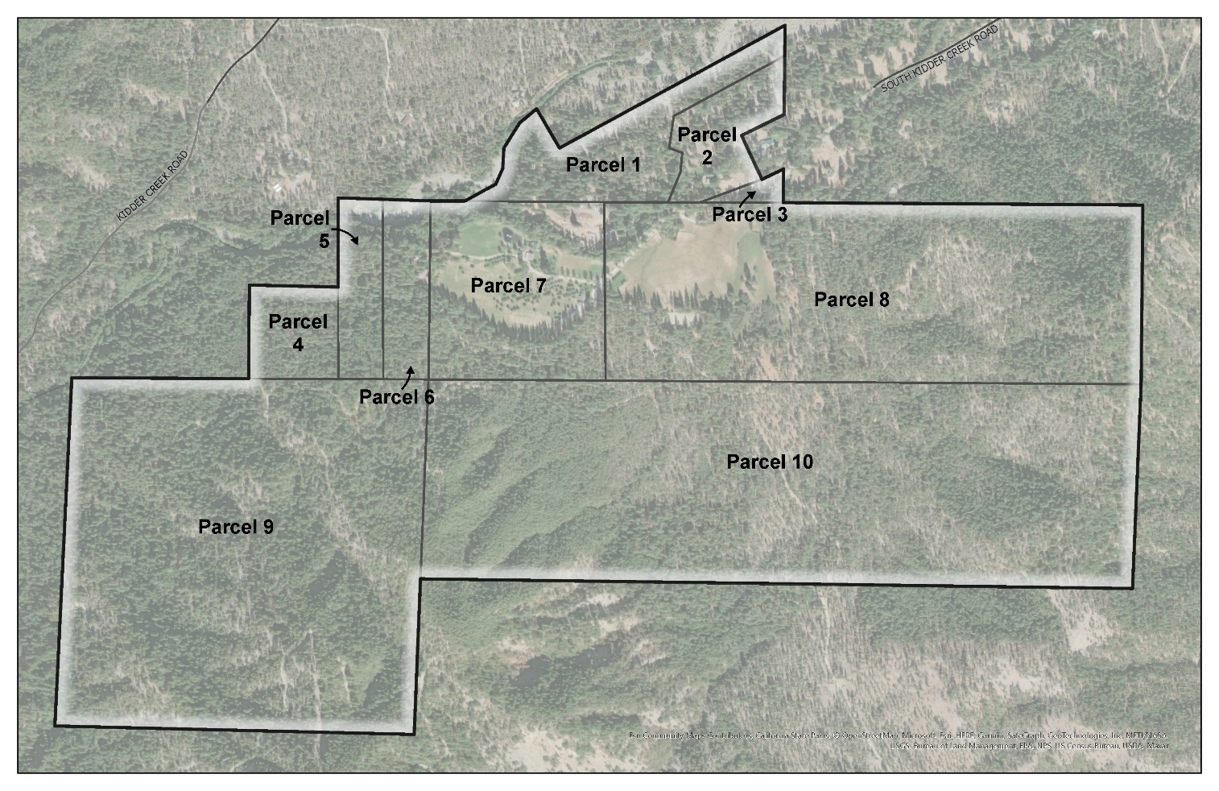Figure 12: KCOC Parcel Map

The California Environmental Quality Act (CEQA)
The purpose of CEQA
In 1970, the California legislature enacted CEQA (Public Resources Code § 21000 et seq.), requiring public agencies to consider and disclose to the public the environmental implications of their actions, as well as to avoid or reduce significant environmental impacts of these actions when it is feasible to do so. The primary purposes of CEQA are to avoid, reduce or prevent environmental damage, and foster an informed and transparent public decision-making process by providing information to decision-makers and the public concerning the environmental effects of projects either undertaken or approved by lead agencies.

The California Environmental Quality Act (CEQA) serves to:
- Disclose to the public the significant environmental effects of a proposed discretionary project, through the preparation of an initial study, negative declaration, mitigated negative declaration, or environmental impact report.
- Prevent or minimize damage to the environment through development of project alternatives, mitigation measures, and mitigation monitoring.
- Disclose to the public the agency decision making process utilized to approve discretionary projects through findings and statements of overriding consideration.
- Enhance public participation in the environmental review process through scoping meetings, public notice, public review, hearings, and the judicial process.
- Improve interagency coordination through early consultations, scoping meetings, notices of preparation, and State Clearinghouse review.

General CEQA principles – baselines
Under CEQA, the impacts of a proposed project must be evaluated by comparing expected environmental conditions after project implementation to conditions at a point in time referred to as the baseline. The changes in environmental conditions between those two scenarios represent the environmental impacts of the proposed project. The description of the environmental conditions in the project study area under baseline conditions is referred to as the environmental setting. Under CEQA Guideline 15125, “the lead agency should describe physical environmental conditions as they exist at the time the notice of preparation is published, or if no notice of preparation is published, at the time environmental analysis is commenced, from both a local and regional perspective.

In regard to KCOC, there has been public comment about the fact that the permit occupancy appears to be exceeded at times, however, the actual use of the KCOC property is the true baseline for CEQA. This issue was addressed in Fat v. County of Sacramento (2002), 97 Cal.App.4th 1270, where the court noted that the preparation of a CEQA document is not a forum for determining the nature and consequences of the prior conduct of a project applicant and upheld the County’s selection of the NOP issuance date as the baseline date for the IS/MND, despite the fact that the Conditional Use Permit for the airport in question had expired many years earlier. Lead agencies must evaluate impacts against actual conditions existing at the time of CEQA review and are not required to “turn back the clock” and evaluate impacts compared to a baseline condition that predates the illegal activity.

Environmental Review
The full FEIR can be found here: https://www.co.siskiyou.ca.us/community-development/page/kidder-creek-orchard-camp).

EIR Preparation and Background
On September 9, 2016, the Kidder Creek Orchard Camp Zone Change (Z-14-01) and Use Permit (UP-11-15) Draft Initial Study/Mitigated Negative Declaration (IS/MND, State Clearinghouse (SCH)#2016092016) was circulated by the County for a 30-day public review period.

CEQA Guidelines Section 15204 recommends that in reviewing negative declarations, persons and public agencies should focus on the proposed finding that the project will not have a significant effect on the environment. If persons and public agencies believe that the project may have a significant effect, they should: (1) Identify the specific effect, (2) Explain why they believe the effect would occur, and (3) Explain why they believe the effect would be significant. Reviewers should explain the basis for their comments, and should submit data or references offering facts, reasonable assumptions based on facts, or expert opinion supported by facts in support of the comments. Pursuant to State CEQA Guidelines § 15064, an effect shall not be considered significant in the absence of substantial evidence supporting such a conclusion.

The County received a number of letters and postcards commenting on the IS/MND. The comments were both for and against the Proposed Project. While many of the comments did not raise concerns about the adequacy of the environmental analysis, there were a number that raised environmental concerns. These comments fell into the following general categories:

- Agriculture: Loss of timber resources
- Hazards: Wildland fires
- Noise: Construction noise and project noise
- Traffic: Emergency access, roadway safety, and traffic increase
- Water: Water quality, stream diversion, and water allocation usage

As a result of comments on the Draft IS/MND, the County determined that an EIR level of analysis was required for specific impact areas. Those areas include agriculture (project and cumulative), hazards (project and cumulative), noise (project and cumulative), traffic (project and cumulative), and water (project and cumulative). These impact areas are the subject of this EIR. All other impact analysis areas defined in Appendix G of the CEQA Guidelines and analyzed in the 2016 Draft IS/MND will not be included in this EIR. However, all mitigation measures identified in these sections, as shown below, will be included as mitigation in this EIR and in the Mitigation Monitoring and Reporting Program (MMRP).

In accordance with CEQA Guidelines § 15082, the County prepared a Notice of Preparation (NOP) of an EIR for the Proposed Project that was distributed to responsible agencies and the public for a 30-day comment period, beginning on August 31, 2018, and concluding on September 29, 2018. One public scoping meeting was held on September 13, 2018, at the Fort Jones Town Hall in order to receive additional comments and input from the public as to the scope and content of the EIR. Comments received in response to the NOP were considered during preparation of the DEIR.

The Draft EIR (Draft EIR) was released for public and agency review on August 7, 2019, with the review period set to end on September 20, 2019. The DEIR contains a description of the Project, description of the environmental setting, identification of Project impacts, and mitigation measures for impacts found to be significant, as well as an analysis of Project alternatives. The Draft EIR was provided to interested public agencies and the public and was made available for review at the County offices and on the County’s website.

The County received a large number of public comment letters and postcards on the DEIR. The County determined that some of the comments received on the DEIR required further analysis of the Project’s potential impact on specific resource areas. As such, in accordance with Section 15088.5 of the CEQA Guidelines, the County determined that the new information brought to light by this analysis merits recirculation of portions of the DEIR. As defined under CEQA Guidelines Section 15088.5(c), “If the revision is limited to a few chapters or portions of the EIR, the lead agency need only recirculate the chapters or portions that have been modified.” Therefore, only those portions related to wildfires, hydrology and water quality, and noise were revised and included in the Partial Recirculated DEIR.

The Partial Recirculated Draft EIR was released for public and agency review on April 5, 2022, with the review period set to end on June 20, 2022. The 2nd Partial Recirculated DEIR was completed to address an unintentional error in traffic average daily trips (ADT) provided in the original and the updated Environmental Noise Assessment for the Proposed Project. The original 2017 noise assessment as well as the 2021 updated noise assessment used traffic ADTs of 1,067. This error in ADTs was commented on in a letter commenting on the DEIR. However, the comment was not discerned until after the Partial Recirculated DEIR was circulated for public review. The actual ADT for the Project is 1,448. As such, the 2nd Partial Recirculated DEIR has been completed to address this increase in traffic ADTs. All other sections of the DEIR use 1,448 ADTs to evaluate the potential for impact to the environment. Therefore, only those sections of the DEIR which are affected by the incorrect ADT count, Section 3.4 Noise and Section 4.0 Alternatives, were recirculated as a part of this 2nd Partial Recirculated DEIR. The 2nd Partial Recirculated Draft EIR was released for public and agency review on June 23, 2022, with the review period set to end on August 8, 2022.

The County received 237 comment letters from interest groups, government agencies, and the public regarding the Draft EIR, and 57 comment letters on the on the Partial Recirculated Draft EIR and 2nd Partial Recirculated Draft EIR.

CEQA Guidelines Section 15091 requires the County to make certain findings for each significant environmental impact identified in an IS/MND or EIR. Except for traffic-related noise under the originally proposed project at 844 occupants, all of the significant impacts of the project will be mitigated, consistent with the following Finding: “Changes or alterations have been required in, or incorporated not, the project which avoid or substantially lessen the significant environmental effect as identified in the final EIR”. As recommended by the Planning Commission, a reduction in occupancy to 622 occupants addresses the impact of traffic noise and causes the impact to become less than significant.

Mitigation Measures
The California Environmental Quality Act (CEQA) requires public lead agencies to impose feasible mitigation measures as part of the approval of a “project” in order to substantially lessen or avoid the significant adverse effects of the project on the physical environment. California Code of
Regulations, Title 14 (“CEQA Guidelines”), Section 15370 defines “mitigation” as
- Avoiding the impact altogether,
- Minimizing the impact by limiting its degree or magnitude,
- Rectifying the impact by repairing, rehabilitating, or restoring the impacted environmental resource,
- Reducing or eliminating the impact over time, through actions that preserve or maintain the
- resource, and
- Compensating for the impact by replacing or providing substitute resources or environmental conditions, including through permanent protection of such resources in the form of conservation easements.

When imposing mitigation, lead agencies must ensure there is a “nexus” and “rough proportionality” between the measure and the significant impacts of the project. (CEQA Guidelines § 15126.4.) All mitigation must be feasible and fully enforceable, and all feasible mitigation must be imposed by lead agencies. (CEQA Guidelines, § 15041.) But if any suggested mitigation is found to be infeasible the lead agency must explain why and support that determination with substantial evidence presented in their findings and a statement of overriding considerations. (CEQA Guidelines, §§ 15091 and 15093.) Mitigation measures may either be integrated into proposed projects or imposed as mitigation for identified significant environmental impacts.

Mitigation measures modify a project “…to substantial lessen or avoid significant effects on the
environment…” thus fulfilling a basic purpose of CEQA to:

“Prevent significant, avoidable damage to the environment by requiring changes in projects through the use of alternatives or mitigation measures when the governmental agency finds the changes to be feasible.” (State CEQA Guidelines § 15002(a)(3))

As a result, the ability to mitigate significant environmental impacts is a key focus of CEQA.

If a lead agency determines, following public review of an EIR, that proposed mitigation measures are not feasible or would not reduce potential effects to a less-than-significant level, it may choose to remove those mitigation measures and substitute other measures.

A link to the Mitigation Measures and the MMRP can be found here: https://www.co.siskiyou.ca.us/sites/default/files/fileattachments/community_development/page/15325/z1401_up1115_d-mmrp_withcorrectedmeasures_v4.pdf.

CEQA Process and the role of the Board of Supervisors

Approving the EIR
CEQA requires the County proceed along one of three paths and find either that:

- The project will not have a significant effect on the environment (and no mitigation measures are required at all); or
- The project will have some significant environmental effects, but all the effects will be eliminated or reduced substantially by mitigation measures.
- The project will have some significant environmental effects and not all of them can be eliminated or reduced by mitigation measures, which then requires the Board of Supervisors to consider potential “alternative projects” and also, possibly, a Statement of Overriding Considerations.

As the otherwise significant impact of traffic noise, the Planning Commission proceeded under option #3 (consider project alternatives) and recommends reducing the occupancy from 844 to 622, also known as Project Alternative Number 4 (with no structure reduction).

Project Alternatives:
A “project alternative” is a “theoretical” modification to a project that would lessen a project’s environmental impacts. Project alternatives are only considered when there is an impact that cannot be mitigated. Generally, a project alternative is balanced against the proposed goals of the project in determining whether the project alternative is reasonable to adopt instead.

Here, the Kidder Creek project identifies a substantial environmental impact as to noise, specifically traffic noise on Saturday mornings, that the EIR analysis does not find can be mitigated to a less than significant level. The Planning Commission found that traffic noise is a significant effect, and the Planning Commission considered the project alternatives. Project Alternative #4 was adopted (reduced occupancy down to 622 persons) because it addresses the noise impact, then the proposed CEQA findings would need to be adjusted accordingly.

Statement of Overriding Considerations:
If a proposed project has a substantial impact that cannot be mitigated and none of the project alternatives are feasible, but the project would otherwise be approved, then the last step is making the Statement of Overriding Considerations (SOC). The purpose of the SOC is to identify that the project has overriding benefits that justify approving the project despite its environmental harm. As mentioned above, no Statement of Overriding Considerations is required if the project is approved with reduced occupancy. However, if the Board were to reject the Planning Commission’s recommendation of the reduction of occupancy, a SOC could be required, and staff would return with an SOC if appropriate.

Disapproving the EIR
A lead agency may refuse to certify a final EIR if it finds that the final EIR is inadequate. An EIR may be inadequate if revisions to the EIR are required to: (1) respond to changes to the project, (2) because of changes in circumstances, or (3) new information arose after the final EIR was completed. If the final EIR must be revised, the revised portions of the EIR may have to be circulated for public review and comment before it is certified.

Comments
The Draft EIR public review process provides an opportunity for the public to refine the analysis of environmental impacts and the development of feasible mitigation for those impacts found to be potentially significant. The public review period for a Draft EIR provides an opportunity to address concerns related to any potential direct or indirect impacts to the physical environment. All substantive comments on the Draft EIR must be addressed by the lead agency in the Final EIR.

Substantive comments that include factual support (such support known as ‘substantial evidence’) can lead to changes to the proposed project itself or to final recommendations as to the project. Comments can specifically point out errors, inconsistencies, omissions of data or analyses, conclusions not based on evidence, or failures to provide discussion required by CEQA. The commentor can even provide additional substantive evidence or information that was not considered in the Draft EIR. The lead agency must consider all substantive comments and information submitted on the Draft EIR and needs to respond adequately to substantive comments prior to certification of the Final EIR.

332 public comments have been submitted regarding this project to date, both from agencies and members of the public. 294 public comments were received during the CEQA public comment periods, while only 38 public comments have been received after the CEQA public comment periods. There have been a number of public comments received in opposition to the project.

The main concerns from the opposition include:
- Incompatibility with zoning and the SVAP.
- The project size and scope are too large for the community.
- Traffic concerns: too many vehicles for the current design of the road.
- Noise concerns: too much noise with the increase in campers.
- Water concerns: the project will negatively impact water users nearby and the camp is incorrectly using their water right.
- Wildfire concerns: the camp will be unable to safely evacuate the number of proposed campers should there be a wildfire.

Recommended Motion

I move to take the following actions:

- Introduce, waive, and approve the first reading of the ordinance, changing the zoning of APN 025-370-380 from Timber Production Zone (TPZ) to Rural Residential (RR).
- Approve a resolution approving: (1) the Kidder Creek Orchard Camp use permit application, (2) the project’s Environmental Impact Report and adopt Project Alternative Number 4, and (3) adopting a mitigation and monitoring reporting plan.

Attachments
- Final EIR (the full FEIR can be found here: https://www.co.siskiyou.ca.us/community-development/page/kidder-creek-orchard-camp)
- (Exhibit A) Draft Resolution
- (Exhibit A to Draft Resolution) Fact of Findings
- (Exhibit B) Mitigation Monitoring Reporting Program
- (Exhibits C and D) PC Resolution 2022-018 and November 2022 Staff Report Package
- County Counsel Memo
- Response by Glenn Pearson to Marsha Burch letter of November 15, 2022
- Response by Chris Cummings to Charnna Gilmore letter of February 13, 2023
- PC Resolution 2023-004 and February 15, 2023, Staff Report Package
- Draft Zoning Ordinance
- (Exhibit A) Zoning Ordinance Map
- PowerPoint to Planning Commission August 17, 2022
- PowerPoint to Planning Commission November 16, 2022
- Wildland Emergency Plan Presentation November 16, 2022
- Draft KCOC Emergency Operation Plan (EOP)
- PowerPoint to Planning Commission January 23, 2022
- February 15, 2023, Meeting Link and Minutes: https://www.co.siskiyou.ca.us/planningcommission/page/planning-commission-meeting-59
- January 17, 2023, Meeting Link and Minutes: https://www.co.siskiyou.ca.us/planningcommission/page/planning-commission-meeting-58
- November 16, 2022, Meeting Link and Minutes: https://www.co.siskiyou.ca.us/planningcommission/page/planning-commission-meeting-56
- August 17, 2022, Meeting Link and Minutes: https://www.co.siskiyou.ca.us/planningcommission/page/planning-commission-meeting-53
- Comments (that have been submitted after Final EIR was posted in August 2022)

As defined by Water Code Section 5100(c): “‘Diversion’ means taking water by gravity or pumping from a surface stream or subterranean stream flowing through a known and definite channel, or other body of surface water, into a canal, pipeline, or other conduit, and includes impoundment of water in a reservoir.”
Generally, mere opinions, generalized statements or hypotheticals do not constitute substantial evidence whereas relevant factual information and potential expert opinion do.

